Word Template for CAA-ACA Proceedings Paper

First Name¹, Second Name², and Third Name²
¹Dept. of XXX, University of ABC, ## St., Province, Country, ZipCode optional-e-mail@yyy.ca
²Name of Company, ### St., Province or State, Country, ZipCode email@yyy.xx

INTRODUCTION (12PT FONT)
This template can by used as a guide for preparing the Proceedings paper. This is what the publication will look like in Canadian Acoustics. This word document uses style sheets. The style for each paragraph can be seen in the Normal view in Word by setting the Style area width to be 0.5 inches or so using Tools|Options|View.
The paper size is 8.5 x 11 inches.
Margins: Top – title page: l.25”; 2nd page 0.75”; bottom l” minimum; sides, 0.75”.
Heading material: full width of page and centred.
Main body of the article: two column format with 0.25 inches between columns.
The title of the article is centred in 14 pt Bold, Times New Roman. Author names are in bold, 12 pt, centred. The text is in 10-pt Times New Roman. If you do not provide this format, however, it will be done for you at the editorial office to conform to this standard, prior to publication. The first line of the paragraph after a heading is indented 0.5 inches.
Skip a line between paragraphs. The style sheet does this automatically. Note there is no indentation in this paragraph.
Or in this one. Only the first paragraph after a heading gets indented. If you have a sub-heading it should look like this below.

1.1 Sub-heading
This is an example of a Sub-heading. (12 pt, bold, Times New Roman). This is indented 0.5 inches too.
If you have a sub-subheading it would look like this below.
Sub-subheading
Above note a sub-sub-heading. More text could follow.

1.2. Another Sub-heading
It is not necessary to use sub-headings of course. Given that the proceedings paper is only 4 double columns, you may find that the primary headings are sufficient.
It is entirely up to you as long as you stay within the general guidelines.
Do not use page numbers. These will be added later.

................................................................................................
............................................................................................
.................................................................................................................................................................................................................................................................................................

METHOD
It is not necessary to begin a new column with a heading, as can be seen on the next page.
Here is an example of a simple equation placed in the text: y = ax + f (z). If the equation is more complex you can segregate it from the text and number it.

2.1 Another Sub-heading
The main headings chosen here, such as the Introduction, Method, Results, and Discussion are simply examples that work well for some experimental papers. Authors are at liberty to use whatever headings they prefer.
...............................................................................................................................................................................................

RESULTS
Insert Figures and Tables in the text. Name as “Figure 1, 2, ...”. Caption in 9 pt with single spacing. Figures will be printed in black and white unless the author wishes to cover the cost for colour.

If you wish, you can place your figure or table across two columns on the page. The examples below however use only one column.
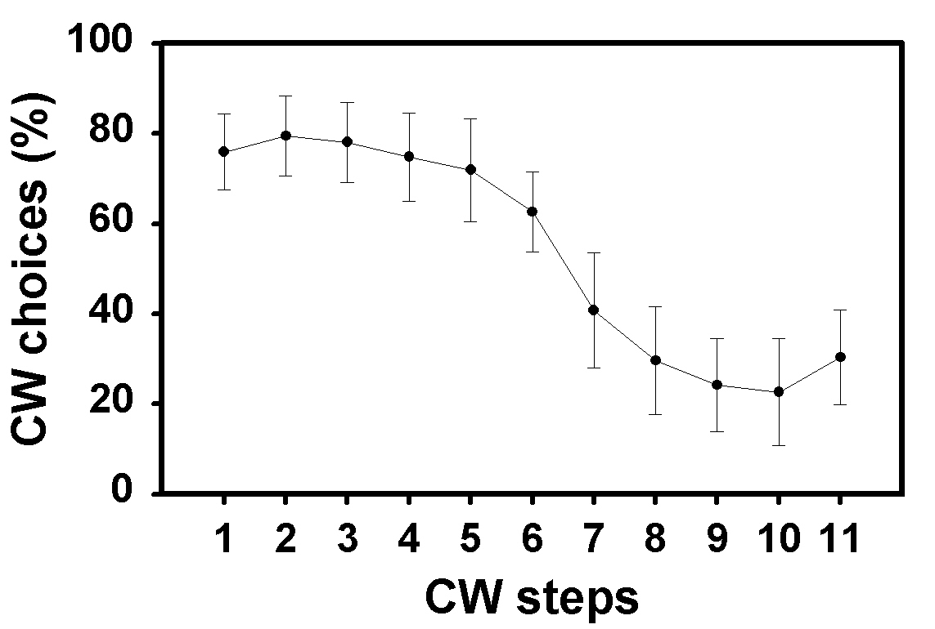
Fig. 1. Mean per cent CW choices as a function of CW steps. Examples of a figure. Note that if there is a second line for the caption, it is single-spaced. Font size is 9.
...................................................................................................................................................................................................................................................................................................
Make sure that your figures are brought into your text as image files (e.g., .jpg, .tif, .wpg, .wmf, .eps, .gif, .png)
......................................................................................................................................................................................................................................................................................

Table 1. Possible format for title of a table.
 | Dimension 1 | Dimension 2
Factor 1 | xx | yy
Factor 2 | zz | aa

................................................................................................................................................................................................................................................................................................................................................................................................

DISCUSSION
There is considerable freedom allowing authors to present the information that they think would be of most value to their readers.
...................................................................................................................................................................................................................................................
...................................................................................................................................................................................................................................................
..............................................................................................................................................................

Once you have completed the word processor file, please create a pdf (Acrobat) file if possible.
.................................................................................
Please submit your one word processor file and the pdf file. If you cannot produce the .pdf file, just send the word processor file to the following e-mail address: papers@caa-aca.ca
..................................................................................................................................................................
For the reference section, use any consistent standard format (American Institute of Physics, American Psychological Association), citing references to works referred to in the text of your article.
.................................................................................................................................................
REFERENCES
Lastname, X. X. (2002). Title of article. Title of Journal, vol#, xx-xx.
Lastname, Y.Y. (1800). Title of article 2. Title of Journal
Etc............................................................................
ACKNOWLEDGEMENTS
You may wish to include a brief acknowledgement section.
AUTHOR NOTES
This is optional too. The work was conducted while Second Name was a student at xx University. The current address is:.................................................................. ...............................................................................................

